SiteLinx
User
Guide

V1.00

Written By
Systems Division,
Burbank CA,

Contents
Contents 2
1 Introduction 4
1.1 Product 4
1.2 Producer 4
1.3 Consumer 4
1.4 Site 4
1.5 Node 5
1.6 Registration 5
2 The Main Display 6
2.1 Nodes Window 7
2.2 Registrations View Window 7
2.3 Message Window 7
2.4 Settings Dialog Box 8
2.5 E-Mail Nodes Dialog Box 9
2.6 E-Mail Notification Addresses Dialog Box 10
2.7 Send E-Mail & Send Current File by E-Mail Dialog Box 11
2.8 Send Product Dialog Box 12
3 Commands 14
3.1 File – New, T 14
3.2 File – Open, T 14
3.3 File – Save, T 14
3.4 File – Save As 14
3.5 Edit – Settings, T 14
3.6 Edit – Remote Sites, T 14
3.7 Edit – Error Notification Addresses, T 15
3.8 Edit – Delete Node, T, Rc 15
3.9 Edit – Delete Registration, T, Rc 15
3.10 Product – Send Product, T 15
3.11 Mail – Send Message, T 15
3.12 Mail – Send File, T 15
3.13 View Normal, no menu 15
3.14 View Detail, no menu 16
4 Getting Started 17
4.1 Program requirements 17
4.2 Before you begin 17
4.3 Setup and Configuration 18
5 Program Utility 22
5.1 Program Purpose 22
5.2 Current Applications that use SiteLinx 22
5.3 Other Applications 22
6 Notes 24

Introduction
SiteLinx is a Windows 95/NT-based network application that integrates LANs (Local Area Networks) into a WAN (Wide Area Network). Thus allowing other network applications to communicate with others (applications and people) without regard for their locations. SiteLinx was designed to act as a distributor of products or packets following the Consumer/Producer model of network applications.
SiteLinx uses TCP/IP as its LAN protocol and MAPI (Microsoft’s Messaging API) e-mail as its WAN vehicle. SiteLinx method of addressing nodes in the network is as follows: [Site Name:Node Name]. A site name must be the name of SiteLinx (its local name); a node name is the name of an application that connects to SiteLinx.
Below is an explanation of components and concepts used:

Product
You can think of it as a network packet. SiteLinx uses products to share information in the network. A SiteLinx product is ‘wrapped’ in a new layer on top of TCP/IP protocol, which we have named ES4000 protocol. Applications wishing to use the services of SiteLinx must comply with the ES4000 protocol. A product has a type, source, destination and usually some data. A product can contain a message, a file or binary data.

Producer
A producer is a node (computer or application) that is able to send a product to SiteLinx. Applications that wish to act as producers send products to SiteLinx only, SiteLinx then decides where the product will be distributed. When SiteLinx receives a product it looks up its consumers table, then sends it to each one that has registered for that product type. Applications may override this behavior by supplying a destination node in the product, when SiteLinx ‘sees’ that a product has a node name in its destination it sends the packet only to that node.

Consumer
A consumer is a node that registers with SiteLinx to receive products of a type. SiteLinx usually does not care about the product contents, or if the product has data. Applications are free to use the data as they see fit.

Site
A Site is SiteLinx and a group of nodes, or just SiteLinx. Sites must have names, the names are used by SiteLinx mainly for WAN communication. A site by default has LAN capabilities. We can enable WAN capabilities by having a MAPI compliant mail program in the computer where SiteLinx is run. When we enable WAN capabilities, we should supply SiteLinx with a list of Site Names and their e-mail addresses if we need outbound WAN communication. Optionally we can supply a list of notification e-mail addresses that will receive messages when SiteLinx encounters errors.

Node
A Node is an application that has a LAN connection point to SiteLinx or an application that has a WAN product registration with SiteLinx. This may sound a little complicated but in reality, the connections are setup in a standard way during program installation, and afterward the connections happen automatically by the applications. When a computer or application in the LAN connects to SiteLinx, it becomes a node. Applications can also become nodes in a site by registering remotely. An elaborate explanation of the above process will be given below in the document. LAN nodes receive products for which they have registered when they are connected to SiteLinx. WAN nodes receive products for which they have registered when we have entered their site name and their e-mail address in SiteLinx Mail Nodes dialog box.

Registration
Product registration is the process that we must use to tell SiteLinx that we want our application to receive products of a type. Applications using SiteLinx are responsible for registering for products, so this is not an issue during setup, however we can enter registrations directly into SiteLinx by editing the SiteLinx file, it is a text file and is very easy to figure out, note that this is rarely necessary. A registration has a product type and a source. There are several types of registrations:
- Global scope, [the source is *:*] this causes SiteLinx to send us the product from any origin
- Site scope, [SiteName:*] we receive the product that matches the site name (and of course always the product type)
- Specific node, [SiteName:NodeName]
- Specific node name, any site, [*:NodeName] Not a very common one, but its there if needed
NOTE: We use the * asterisk symbol, legacy from MS-DOS, to denote ‘all’, a so called wildcard.

The Main Display
The following screen shot shows the SiteLinx screen for a typical installation.
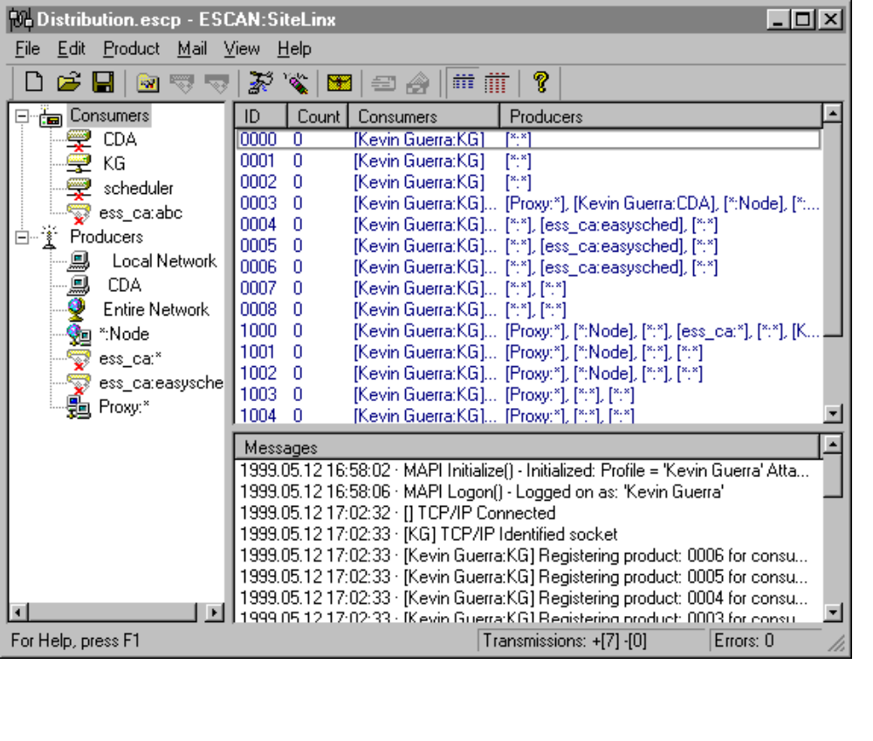

The main SiteLinx screen is split into three main areas.
- The left-hand window shows the Consumers and Producers. It is know as the Nodes Window. You can click on a node to view its registrations and counts of products received. You can right click to remove a node.
- The top right window is the Registrations View Window. It displays the product ID or type, a counter (which displays the products that have been processed since SiteLinx started), and the consumer or producer. You can right click to remove a registration.
- The bottom right window displays the message log. This log records everything that occurs in SiteLinx. SiteLinx saves everything that is displayed in the file ESCANSiteLinx.log.
The main window has a toolbar that has the most commonly used menu commands. The toolbar can be hidden or displayed. At the bottom of the main window is the status bar, which can also be hidden or displayed. The status bar contains three sections: a) Command help; b) Transmissions, [+ indicates product transmissions that were successful or valid, - indicates invalid transmissions, such as when an application does not ‘know’ the correct SiteLinx protocol and sends data anyway]; and c) Errors, any data errors that may occur during product transmission.
The amount of space allocated to each of these sections can be changed by clicking left over the dividing lines and dragging them around.
For convenience to the user the window settings and positions are saved and restored at program startup.
The following sections describe each of these areas in more detail. These descriptions are fairly high level. Subsequent sections will explain how to perform specific tasks.

Nodes Window
The Nodes Window contains a tree view list of nodes. Each node has an icon:
Disabled remote node, Remote node, Disabled consumer node, Consumer node, Unknown producer node, Local producer node, Any node, Specific node from any site.

Registrations View Window
This window contains a view to the consumer registrations. There are two types of views normal view and detail view. The normal view displays the product type, a counter and a list of producers (or consumers if viewing a producer node) in the same row. The detail view displays the same but each producer or consumer goes into one row.
When in normal view you may sometimes notice … three dots just before the column header dividing line, this indicates that the text does not fit in the column. If you wish to view the text you may increase the column size by left clicking the column header dividing line and dragging it to the right, or you may double click on the text to bring up a message box that will attempt to display all the text, the message box only appears when the text does not fit in the column.

Message Window
The Message window is used to record everything that occurs in SiteLinx. Color coding is used to distinguish the different types of information recorded. The following broad categories are used to distinguish the messages.
- SiteLinx operational messages are shown in black. These messages record things such as connections, disconnections, product registrations, node identification, etc...
- Warning messages are shown in rust.
- Error messages are shown in bright Red.

Settings Dialog Box
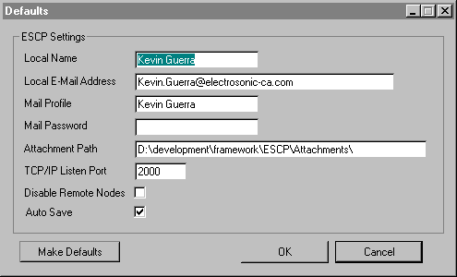The settings or defaults dialog box contain variables that SiteLinx uses for its operation. These variables are typically set during SiteLinx installation and usually remain unchanged. Following is an explanation on each of the settings:
- Local Name is the name of the site. In the current version of SiteLinx we are required to set the Local Name to match the e-mail address, if there is any. When using Exchange as the MAPI compliant e-mail transfer program the Local Name should match exactly with the exchange e-mail address not with the internet address, for example Kevin Guerra is an Exchange address whose internet address is Kevin.Guerra@electrosonic-ca.com so we use Kevin Guerra because that is the Exchange address. When using another program for e-mail, for instance Outlook Express, to connect to an internet service provider, we must use the internet e-mail address name only, for example if our address is ess_ca@earthlink.net the Local Name must be ess_ca.
- Local E-Mail address must be the full ‘internet’ address. This is because SiteLinx uses internet e-mail addressing even when using Exchange.
- Mail Profile is the name of a valid MAPI profile in your computer. MAPI compliant e-mail applications create a profile for you during their installation. Users may create other profiles usually this is the case when the computer is used by more that one user. You may view a list of profiles from the Windows System Control Panel, by double clicking the Mail icon, for details on that consult your e-mail program documentation. For a typical SiteLinx installation it should be sufficient to click on the ‘Make Defaults’ button, this causes SiteLinx to fill in default values for you and one of the values is the Mail Profile that corresponds to the default MAPI profile in your system. Before you click on this button make sure you haven’t yet entered any values because you’ll have to re-enter them, also make sure you startup your e-mail application to check if you have any unread e-mail. If you do flag it as read by clicking on the unread message and then clicking on another message, otherwise SiteLinx will process all unread messages and then delete them.
- Mail Profile Password must be given only if your profile has one, otherwise leave blank.
- Attachments Path must be a valid path in your local hard drive where SiteLinx will save any attachments that you receive via regular e-mail. NOTE: SiteLinx was designed to read and process all e-mail, after the messages are processed they are deleted from your inbox, this is done to save space in your inbox. When SiteLinx deletes messages from your inbox it saves the attachments if any in Attachments Path and your messages are stored in the file ESCANSiteLinx.msg, it is a text file and can be opened with Notepad.exe, do not double click on the file because the e-mail readers try to open it as a message and they will error. If you send e-mail that cannot reach its destination some isp’s send you an undeliverable message report, SiteLinx understands some of them and saves them in the file ESCANSiteLinx.und, also a text file. These two files mentioned above reside in the SiteLinx installation directory. Because SiteLinx may use e-mail in high volume it is recommended that the e-mail address provided to SiteLinx is left for exclusive use by SiteLinx. In the next version we may have SiteLinx leave regular e-mail unprocessed as an option.
- TCP/IP Listen Port. SiteLinx as you know is a network application which uses TCP/IP as its protocol. Applications that wish to connect and use the services of SiteLinx do so by specifying the TCP/IP address of the computer where SiteLinx was installed; in the form of the computer name as appears in the properties in the network neighborhood icon or in the 4 byte notation 234.12.47.230 for instance, and by specifying a port. Therefore TCP/IP Listen Port is the port that SiteLinx uses to ‘listen’ for new connections. When setting up this variable make sure the port number is not taken by other application in the network.
- Disable Remote Nodes. When it is checked it disables all e-mail capabilities, it also disables several menu items and several toolbar buttons that relate to e-mail. If you want SiteLinx to use e-mail to connect to other sites leave it ‘unchecked’. NOTE: By default it is ‘checked’ to prevent SiteLinx from processing any e-mail you may have in your inbox.
- Auto Save. During the normal operation of SiteLinx changes occur. SiteLinx saves settings, e-mail addresses, notify addresses and registrations to a file. When an application connects to SiteLinx and registers for products it causes changes in SiteLinx document file, when you change a setting or add an e-mail address you cause changes in the file as well; Auto Save ensures that the changes are saved to the file right away without user intervention and without prompting. When Auto Save in unchecked and changes occur in the document SiteLinx will prompt the user when closing the current file, creating a new file, opening a new file or shutting down SiteLinx. It is recommended to have Auto Save ‘checked’ because it ensures that all the changes are saved right away.
- Make Defaults fills in the dialog box with default values. Care should be taken before clicking this button as it will overwrite any values you may have had. If you accidentally click this button you can always click on the Cancel button, but if you click the OK button they will be saved to the file right away if the Auto Save feature is enabled. NOTE: When you create a new file SiteLinx fills in defaults for you, so clicking Make Defaults after a new file was created is redundant.

E-Mail Nodes Dialog Box
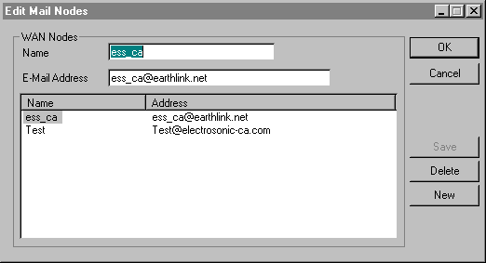This dialog box is used to add e-mail addresses that have SiteLinx in operation and that will act as ‘Sites’. SiteLinx uses these addresses to map a Site Name to an e-mail address. SiteLinx enables nodes to address other nodes through the addressing method [SiteName:NodeName]. The addressing method enables applications to share data without regard for their location in the network, therefore ‘all’ ‘sites’ that will participate in the LAN/WAN must be entered in this dialog box. Here we enter the names as will appear in the SiteLinx Nodes Window and their e-mail address. Recall that the Name must be the internet name, not the Exchange or other name.
To add an new address or site click on the New button, then change the values in the edit controls and click on the Save button when done.
To edit an entry click on the entry name in the list box, the name not the address, change the values and click on Save.
To delete an entry click on the entry name in the list box and then click on the Delete button.
When done making changes to the list click on the OK button to save the changes or click on the Cancel button to undo all the changes and close the dialog box.

E-Mail Notification Addresses Dialog Box
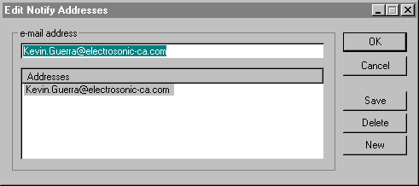This dialog box is used to add addresses of ‘people’ that will be notified if any errors occur in SiteLinx. Any error in SiteLinx (recall that messages will be displayed in bright red in the Messages Window) will generate an e-mail message that will be sent to ‘all’ the e-mail addresses in this list. Work is in progress to regulate this behavior and allow the user to control which messages will generate e-mail. The operation of this dialog box is almost identical to the previous one, see previous section for details.

Send E-Mail & Send Current File by E-Mail Dialog Box
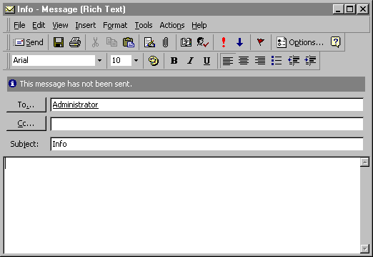These two dialog boxes are standard MAPI dialog boxes used to send e-mail. You may use them to send standard e-mail. The second dialog box add the current SiteLinx file as an attachment. For details on MAPI dialog boxes seek help in your MAPI compliant application.

Send Product Dialog Box
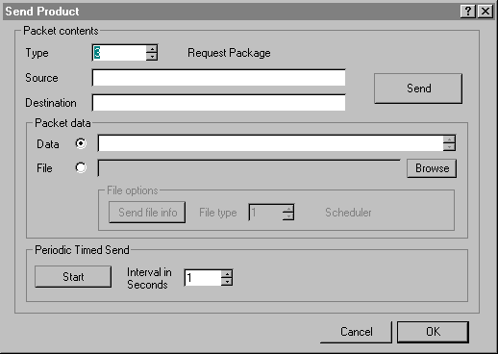This dialog box is provided mainly for aiding in debugging other applications in the network. It enables you to ‘create’ products and to send them anywhere in the network. Following is an explanation on its usage:
- Type is the product type or ID. We have given names to some types that we currently use in our applications, and they appear to the right.
- Source, if blank the product is from [*:*] or global. You can change this default value to ‘impersonate’ another node.
- Destination, if blank the product will go to all the nodes that have registered for this product type. If you supply a value that has a site name and a node name the product should reach its destination even if the destination hasn’t registered for it. If you supply a site name but not a node name [SiteName:*] the product will go to that site only and the SiteLinx application in that site will distribute to all nodes that are local and have registered for that product.
- Data is a multi line edit control you can use it to type the data to be sent.
- File. If your application requires binary data, put that data into a file and send the file. If your application expects a file, as it is the case in some product types, click on the ‘Send file info’ button and select file type 1 for the scheduler, file type 0 when the file type does not matter, or take a new file type that only your application will use.
- When you are ready preparing your product click on the send button. You should notice an increase in the Transmissions section in the status bar, except when there are no current local connections or no remote registrations.
- Periodic Timed Send. When you click on the start button it causes the current product to be sent at set intervals, the button text changes to Stop, if you click again it goes back to its original state and stops the timed send operation.

Commands
SiteLinx commands can be executed in three ways: a) Menu selection; b) Toolbar button click; and c) Mouse right click. Most SiteLinx commands have a menu selection, most have a toolbar button and two can be executed with the mouse by right clicking. Below is an explanation of the commands. We’ll label each command to indicate how we can invoke it, as follows: Most SiteLinx commands have a menu item, so the tile will indicate it’s menu path or ‘no menu’ will be indicated, T-toolbar, and Rc-right click.

File – New, T
Creates a new SiteLinx file, as explained above the file would contain registrations, e-mail and notification address. When creating a new file make sure you change the settings. Typically SiteLinx will find appropriate default settings with the exception of Local Name and Local E-Mail address, those must be changed, and you must uncheck Disable Remote Nodes if you want e-mail support.

File – Open, T
Opens an existing SiteLinx file. When you open an existing file keep in mind that SiteLinx uses the settings from the file you just opened, so it is advisable to check the settings.

File – Save, T
Saves the current SiteLinx file. This command is unnecessary if you have selected the Auto Save feature.

File – Save As
Creates a new SiteLinx file, copies the contents of the current file and makes that new file the current one. NOTE: When SiteLinx starts up it opens the last file used.
NOTE: Print related commands are not used in SiteLinx version 1.0, they were left there to be elaborated in a future version.

Edit – Settings, T
Brings up the Edit Settings dialog box.

Edit – Remote Sites, T
Brings up the Edit Mail Nodes dialog box.

Edit – Error Notification Addresses, T
Brings up the Edit Notify Addresses dialog box .

Edit – Delete Node, T, Rc
Prompts the user to delete the selected node from the Nodes Window. NOTE: Deleting a node causes SiteLinx to delete all the registrations for that node, it does not disconnect the node but it does remove it from the view. If the node that you just removed registers for a product again it will be displayed again. In other words, we do not currently support disabling of a node permanently from the network.

Edit – Delete Registration, T, Rc
Prompts the user to delete the selected registration from the Registrations View Window. NOTE: Deleting a registration from the view causes SiteLinx to remove that registration for the currently selected node, so that when a product of the type just deleted reaches SiteLinx the currently selected node will not receive it, of course this does not apply to products that are addressed directly to that node. When your current view is normal and you delete the registration it will remove all the registrations for that type for all nodes in the row; if your view is detail only one node per row is in view so only the registration for that type for that node will be removed.

Product – Send Product, T
Brings up the Send Product dialog box.

Mail – Send Message, T
Brings up the MAPI send message dialog box.

Mail – Send File, T
Brings up the MAPI send message dialog box and attaches the current SiteLinx file.

View Normal, no menu
Is the default view for SiteLinx. It is used to switch back to normal view. Allows to view all the registrations for one product type for the currently selected node.

View Detail, no menu
View registrations in detail. Allows to view one registration per product type for the currently selected node.

Getting Started
This section should help you get SiteLinx up and running with minimum effort in a basic installation.
SiteLinx installations can fit in two categories:
- LAN operation only
- WAN operation, includes LAN by definition.
If you need help deciding which one is best for your company or application, please consult Electrosonic personnel.

Program requirements
General requirements for LAN operation only:
- Windows 95/NT
- Microsoft Windows 95/NT compliant network, or use the built in network capabilities of Windows. In either case, the network must support TCP/IP and this must be done through Windows Sockets v.2 specification.
- Memory requirements vary according to program usage and network traffic volume. Typically the computer where SiteLinx will run would require a minimum additional memory, besides the memory required by the OS and other TSR’s you may have, size of approximately 10 megabytes. Typically would be about 50 meg minimum for an NT system.
- Sufficient disk space for the installation and for the program operation, about ???
WAN operation requirements, these are in addition to the ones mentioned above:
- MAPI compliant e-mail system.
- An internet e-mail address.
- Additional memory and disk space to support the MAPI system.

Before you begin
It is helpful to know in advance the following:
- Will your network be a WAN?, if so you may want to sketch a network layout and write down the site names. Remember that for this version of SiteLinx the site names ‘must’ be the internet address names, these you will enter in the Edit E-Mail Nodes dialog box along with their corresponding full e-mail address. Also keep in mind that the Local Site Name must be the internet address name for internet e-mail ‘or’ the e-mail address, not internet address, for systems that use Exchange as their e-mail program. So ‘note’ that if for example you use Exchange in your local site and your e-mail address for exchange is [Kevin Guerra], your local nodes and your local SiteLinx installation will use that name as local, ‘however’ remote sites will use your internet address name [Kevin.Guerra]. It is important to keep this in mind for SiteLinx version 1.
- Assign names to the applications that will connect to SiteLinx. This can vary from application to application, so consult the application in question’s documentation for details. Currently Electrosonic has two application that can be part of a SiteLinx network, ESCAN:Scheduler & ESCAN:PC-Monitor, actually the Scheduler acts as a producer and causes SiteLinx to send e-mail when required. Follow the guidelines in those application. Make sure, of course, that each application has a unique name. When two applications share the same name, SiteLinx will send the product to both, this may or may not be the desired effect, in most cases it is not.
- Gather the names of the computers that will have SiteLinx installed, the computer name can be obtained by right clicking the network neighborhood icon in the desktop and selecting properties. You will need this computer name to configure the applications that will connect to SiteLinx, if you prefer you may also use the 4 byte internet address notation instead of the computer name.
- Select a Listen Port for SiteLinx, and make sure that port number is not taken by any other application in your LAN, if this happens you will receive an error in the messaging window displaying the error information.
- If your system will be a WAN, make sure your e-mail system is installed. If you use Exchange and you receive your e-mail through another computer in your LAN, no e-mail configuration changes should be required. However if you will connect to the internet to receive and send your e-mail, you must configure your e-mail system according to the following guidelines:
- Make sure, of course, that your system is able to dial up, connect, send and receive e-mail, and you may also want to send messages to the remote sites you will access to ensure that your information is correct.
- Setup your e-mail system to dial-up at set intervals. The frequency depends on your application and the amount of traffic. To help you decide which one is best for your company or application please contact Electrosonic Systems, Inc. When a dial-up connection is established MAPI notifies SiteLinx, it then attempt to download any e-mail and send any e-mail it may have pending. SiteLinx processes the e-mail simultaneously, this happens automatically.

Setup and Configuration
This section will describe what to do to get the system up and running:
- Make sure you have read and understood the above concepts and procedures. We understand that the Consumer/Producer Model is fairly new and not so well known as for example the Client/Server Model; suffice it to say that they are both Network Models and actually work somewhat similarly. In any event, if you need help with understanding this manual, or if you have comments or suggestions about it, feel free to contact Electrosonic Systems, Inc.
- Make sure you know how your system should operate after SiteLinx is installed. This is important because SiteLinx was designed to be a generic network application, so that it can be used in a wide variety of application. So it is essential to know how your system will operate. For example, a typical installation would include SiteLinx and Scheduler; Suppose you have two sites, say New York and LA, you are in LA, you want to be able to update the 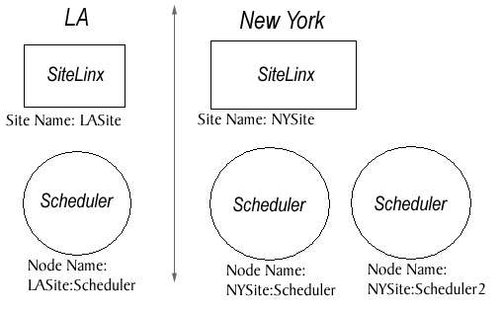Scheduler file in New York. With is information we can sketch the following outline:

Configuration information example: NOTE: Names are case sensitive and allow spaces.
LASite: Installed in a computer names SERVER02, NOTE: this site connects to the internet.
- Local Name: LASite
- Local E-Mail Address: LASite@compuserve.com
- Mail Profile: MS Outlook LASite
- Mail Password:
- Attachments Path: C:\Program Files\ESCAN\SiteLinx\Attachments
- TCP/IP Listen Port: 2000
LASite:Scheduler:
- Local Name: Scheduler
- Address (Computer Name): SERVER02 NOTE: this is where scheduler will connect to, and should match the computer name where SiteLinx was installed.
- Port: 2000, NOTE: this should match the TCP/IP Listen port in SiteLinx.
NYSite: Installed in a computer names NYDISPLAY07, NOTE: this site uses Exchange as its e-mail application
- Local Name: Display Server
- Local E-Mail Address: Display.Server@NYBuilding.net
- Mail Profile: MS Exchange NYSite
- Mail Password:
- Attachments Path: C:\Program Files\ESCAN\SiteLinx\Attachments
- TCP/IP Listen Port: 2000
NYSite:Scheduler:
- Local Name: Scheduler
- Address (Computer Name): NYDISPLAY07
- Port: 2000
NYSite:Scheduler2:
- Local Name: Scheduler2
- Address (Computer Name): NYDISPLAY07
- Port: 2000

After we have the configuration data, we must make a list of sites that will be entered in the Edit E-Mail Nodes Window, recall that here we will use internet e-mail addresses, as follows:
In LASite SiteLinx write: Name: Display.Server Address: Display.Server@NYBuilding.net, notice the dot, this is ‘not’ the Exchange address but the Internet e-mail ‘name’.
In NYSite SiteLinx write: Name: LASite Address: LASite@compuserve.com
Next proceed to install SiteLinx and other application according to the setup instructions provided in the installation program.
After you have installed your applications in each site, run SiteLinx. When you run SiteLinx for the first time it creates a new SiteLinx file unnamed Untitled, unnamed because it hasn’t been saved, so it’s not really a file yet. SiteLinx adds default information into that new memory file. Think of an appropriate name for the file and save it. When you save note where it is saved if you should need to reference that file later. The next time you run SiteLinx it will open the last used file. Normally you only need one SiteLinx file that will require no changes from the user, although the user is required to change the file by editing the appropriate dialog boxes if the e-mail addresses change, of course.
Enter the configuration information that you gathered. If there is a contact person that would receive error notifications enter their internet e-mail addresses in the Edit Notify Addresses dialog box. Click on the save button if you hadn’t selected the Auto Save feature.
SiteLinx should be up and running. At this stage SiteLinx waits for LAN connections, receives e-mail when it arrives, if the e-mail is from another SiteLinx location it decodes it to compose a product, etc…
In the above example the system supports WAN (two types of e-mail systems), and the Scheduler. When you startup ESCAN:Scheduler it will establish the connection to SiteLinx automatically, given that you have entered in it the correct configuration information. ESCAN:Scheduler does not currently need to register any products with ESCAN:SiteLinx, this is because in version 1.07 the scheduler acts as a producer only, it’s capable of sending messages to SiteLinx in the form of packet type 0. Such messages can be standard messages, errors or warnings, recall that if SiteLinx receives an error message it ‘will’ notify whom you have entered in Edit Notify Addresses dialog box.
In addition to sending messages to ESCAN:SiteLinx, ESCAN:Scheduler was designed with built in support for communicating with other schedulers in the network through product types 6 and 7, request update and receive update. It uses a direct method of addressing other nodes bypassing (in these two instances [type 6 & 7]) the Consumer/Producer model. Therefore do not use the wildcard * when sending schedule files across the network, use instead the direct addressing method [SiteName:NodeName]. Recall from the last example this would for instance [LASite:Scheduler].When you send a schedule file to another scheduler, the destination scheduler receives it, saves the file with the name provided by the sender (this is automatically the current file name), and loads it. Refer to the scheduler documentation for more details.

Program Utility
SiteLinx is a network implementation of the Consumer/Producer model. This model enables applications in the network to send and receive data. One analogy would be television stations, they would the producers, and several television sets, consumers. A TV station transmit its programming regardless how many TV sets are switched on, or if any. Now suppose you turn on your TV set and one TV station is off the air, say for repairs, you can switch the dial and tune into another station. ESCAN applications however can always be ‘tuned in’ to receive any type of product, and do with the data as they see fit. For example we may have a ESCAN utility to graphically display network status data, while another utility would be displaying that same data in detail in a textual form.

Program Purpose
General:
- Integrate LANs into a WAN.
- Provide network support for the Consumer/Producer model.
- Allow ESCAN applications to be ‘aware’ of other applications in the network of the same type or a different type, and communicate with each other any way they need, while preserving application integrity and independence from others.
Specific:
- Share files. ESCAN:Scheduler now supports this feature.
- Report application errors to SiteLinx so that it can take the necessary measures, such as notifying users responsible for taking care of those errors or problems.

Current Applications that use SiteLinx
ESCAN:Scheduler. Scheduler uses SiteLinx as explained above.
- ESCAN:PC-Monitor, indirectly through Scheduler. PC-Monitor is a device of Scheduler and notifies Scheduler when computers startup and shutdown and when applications startup and terminate. The Scheduler user creates triggers and can set the trigger to generate an e-mail message.

Other Applications
The error reporting method used by PC-Monitor and Scheduler can be enhanced by:
Making SiteLinx a device of Scheduler
- Allow the user to add SiteLinx e-mail notification categories, so that a particular type of error will generate e-mail messages for a particular group of users.
That way we would have greater flexibility in the way we report messages, warnings and errors to the users.
Another application would be to use PC-Monitor data to generate products that another ESCAN application would use to display network status.
Yet another application could be one that gathers network data periodically and produces reports that will e-mailed to a group of subscribed users.

Notes
A note about notes, they are considered very important and for readability in context were placed all throughout the document, so read them carefully and make sure you understand them.
- Note that SiteLinx does not display its local name in the Nodes View Window, however they local name is displayed in the Registrations View Window.
- Highlight are used in the Nodes View and Registrations View windows.
If you need help with this document, please contact Electrosonic Systems, Inc. personnel.

